The Number of Standard and of Effective Multiple Alignments
A. Dress, B. Morgenstern, J. Stoye
Appl. Math. Lett., Vol.: 11, No.: 4,1998, pp. 43-49
Abstract
We study the number of all possible alignments of N sequence, N≧2, for two distinct alignment concepts proposed in the literature—standard alignments and effective alignments (consistent equivalence relations).
- Introduction

- The Number of Standard Alignments
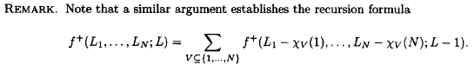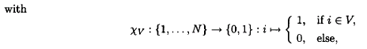
- The Number of Effective Alignments
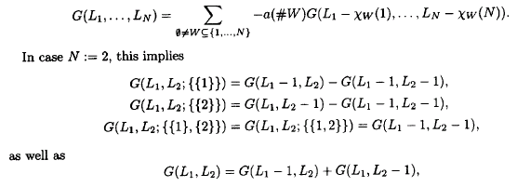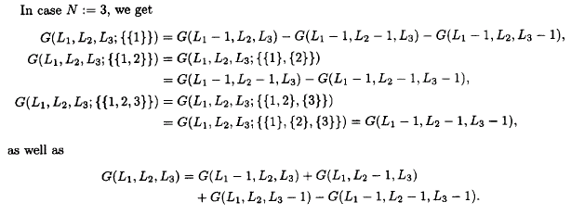
Created by: Chia-Mao Huang
Date: July 5, 2000

